**Exponential equations**

$$\frac{{d(e}^{ax})}{dx}=ae^{ax}$$

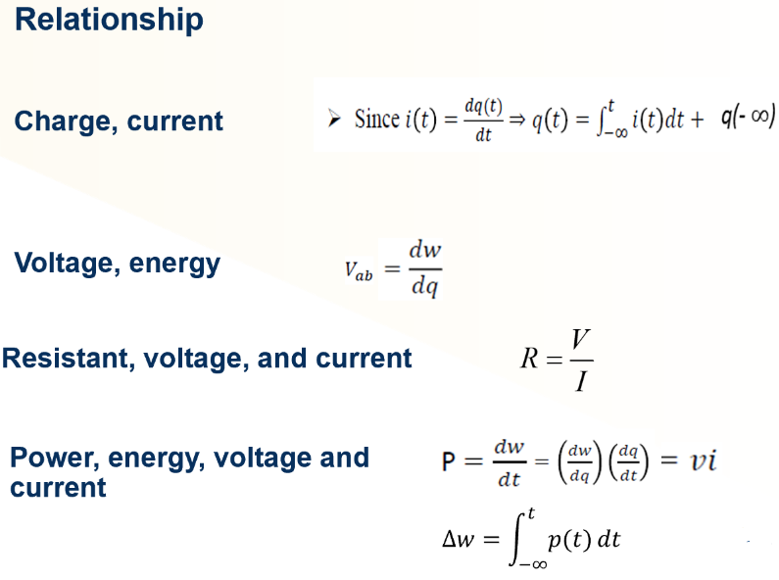

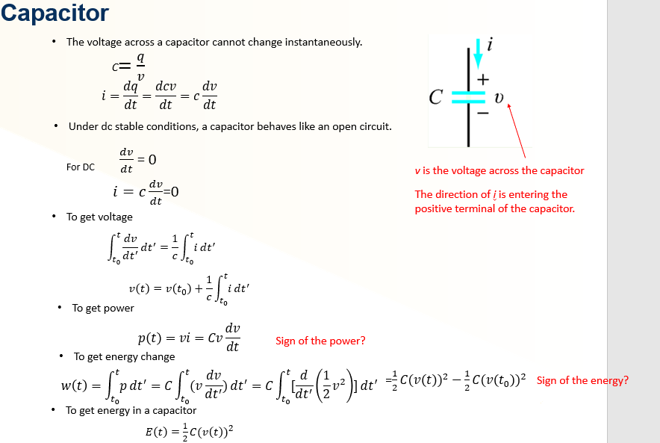

**Capacitor charge and discharge**

